BEACHSIDE HS BOYS SOCCER ANNOUNCEMENT
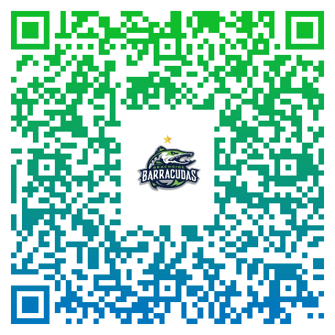

IF YOU ARE INTERESTED IN TRYING OUT FOR THE BOYS SOCCER TEAM, PLEASE REGISTER BY EITHER:
- Scanning the QR Code above
- Or… Visiting the BEACHSIDE HS WEBSITE (ATHLETIC SECTION)
- Or… Clicking link on our IG bio @beachsidesoccerboys

*INFORMATIONAL MEETING*
MONDAY SEPTEMBER 14th (Beachside Cafeteria - 4:15pm)


TRYOUTS BEGIN MONDAY OCTOBER 12th @ Beachside HS
THANK YOU!
COACH MARK FORRESTER - HEAD VARSITY COACH
COACH ROB HOPKINS - JV COACH

